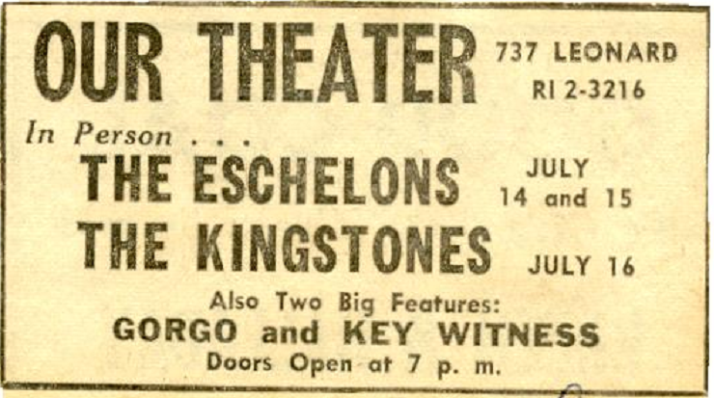

c. 1961-2?
Courtesy of Bruce Snoap; Kingtones Scrapbook # 1

Gorgo is a 1961 British Giant monster movie. Directed by Eugène Lourié, it tells the story of an underwater monster's capture off the coast of Ireland. The monster is taken to London to be featured as a circus attraction.
- Key Witness (1960)

Directed by Phil Karlson. Starring Pat Crowley, Dennis Hopper, Corey Allen. An average Los Angeles citizen witnesses a gang murder when he stops to use a telephone.

